WEBSITE USER GUIDE
This is a sample document and not a complete user guide.

CREATING AND MANAGING CONTENT

Quick Start Guide
Use this handy reference for ongoing content management in Drupal 9.

Refer to the rest of the document for detailed instructions and information on the templates used to create content pages, how to manage your content lifecycle using this system, and when to reach out to the Content Administrators for assistance or guidance.

Logging In to the Drupal Content Management tools
- Go to: https://nrcs.staging.platform.usda.gov/user/login
- Enter your Username and Password
- Once logged in, select the Manage from top tool bar and then select Content to begin working
- If this is your first-time logging in, select your name from the top tool bar and then Edit Profile to update your password to one you can easily manage

Adding a New Content Page

  - Select the Content option from the Admin tool bar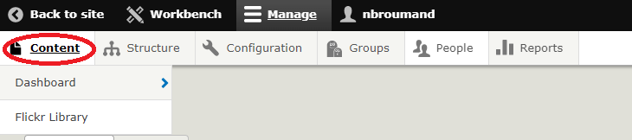
  - Select +Add Content
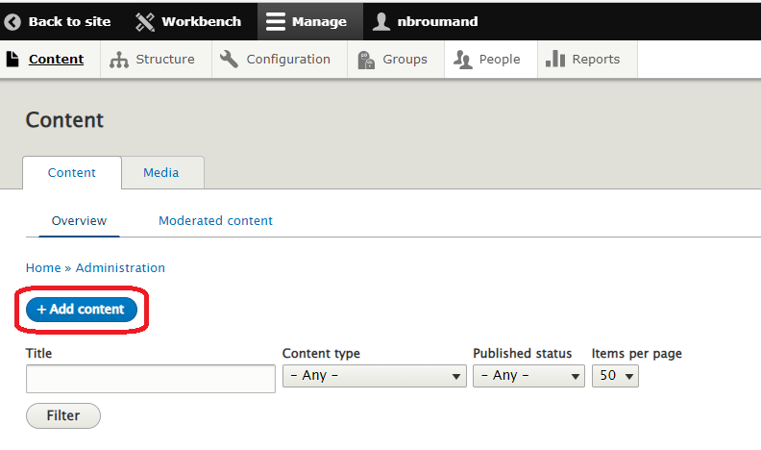
  - Select the Content Type for the page you want to create
This loads the approved Content Type template form, which guides you through creating your new content page
  - Fill in the content fields with your content, required fields must be completed in order to save your work
  - Select any images, PDFs, or other elements you want associated with the content from the
Media library. The content templates have fields to add these materials as needed
  - Add any related content links in the appropriate form area. You can add content links in a variety of ways, including by typing the title of a related page, browsing the media library to select, and adding text with a related URL for external links
  - Select the related taxonomy fields. The content templates have pre-defined fields to help you select the right terms for your content
  - Select the Group/Content Owner that will own the content from the dropdown
Note: if you are only a member of one Group, your drop-down menu will only have those groups listed
  - Select Add to Group to complete this step
  - Select your Publishing State as Draft
There are three different publishing states in your Drupal content management tools: Draft = to save content as you are working on it prior to approval review and edit content
Needs Review = keeps this content in draft view until you finalize the content
Published = once review is complete and the page is finalized, changing the status to Published will send the latest to the public site.
  - Select your username and Log Out when your work is completed

Editing a Content Page
- Within the Content tab, Select the Content Type from the dropdown menu
- Enter the title of the Content you want to edit
- Select ‘Filter’
- When you see your content, select ‘Edit’ from the button in the far-right column, your page will load
- Make your necessary edits
- Select the Publishing State as Draft
- Save your edited page as a Draft (if approval is required) to initiate Approver review.
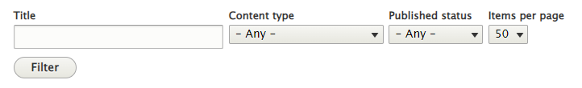

Publishing Content – Web Team Only
- Using the Drupal content manager, select Unpublished to see a list of content that are in Draft or Needs Review status
- Select Edit or the Title of the content to load the page
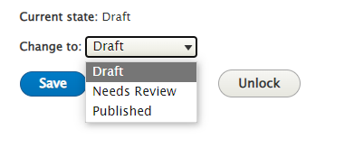
- Review the content to ensure all information is complete
- Add the URL Alias, as needed, to create the path to the content
- Select Published as the Publishing State
- Save to Publish the content

Logging in
Logging into your website is the door to managing your website content and users. This is where you access the website’s back end to make changes to the front end.

Definitions:
- The back-end is where you make changes to the content, webpages, media, photos, user permissions, and more.
- The front-end of the website is the face of the website: what everyone on the internet sees.
To login in, go to:
- https://nrcs.staging.platform.usda.gov/user/login
- Enter your username and password
- The login page should look like:

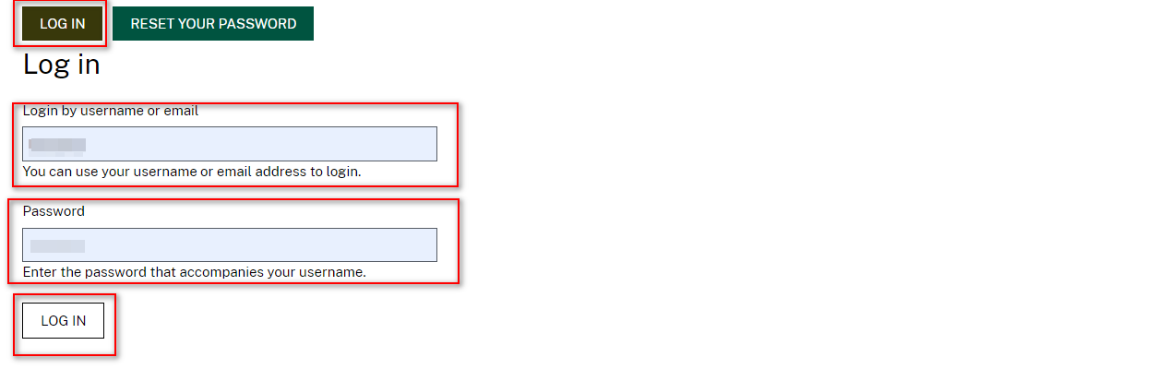

 Bookmark this page. It will help you easily log in the future since there is no visitor-facing link on the website.
After 30-minutes of inactivity, your account can automatically be logged out. Avoid inactivity in order to not lose your work and/or build your content out (e.g., Notepad, Word, etc.) of Drupal and copy/paste when you are ready. You should be able to log back in unless your account has been blocked. If your account is blocked, contact the Web Team (your website administrator).

Admin Navigation
Once a user is logged in, users will notice multiple tabs and sub-tabs on the far left top of the page. These views will vary by user access role and permission (e.g., Admin may see more permissions than a publisher). Below are few examples of that navigation views:
- Workbench View and Tabs:
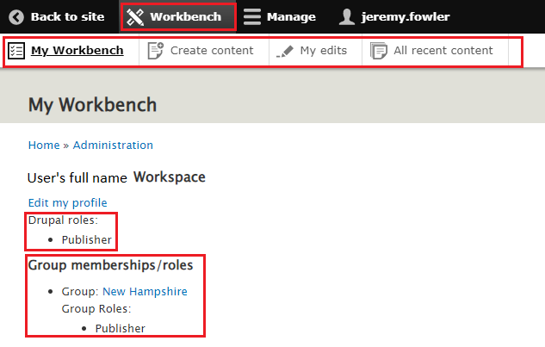
Group ownership and role for the user is indicated here.
Note: Clicking on the Group (e.g. New Hampshire) is the quickest way to access your group’s landing page is to select the Group hyperlink, in this case being New Hampshire.
If you do not have a link for Group, it means that you are an admin with access to all groups.

- Manage View and Tabs:
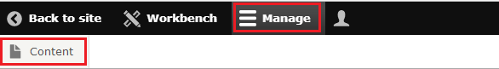

Creating, Editing & Publishing Content using Content Types

Once you are logged into the site, select Manage, select Content, from the toolbar to view all contents.

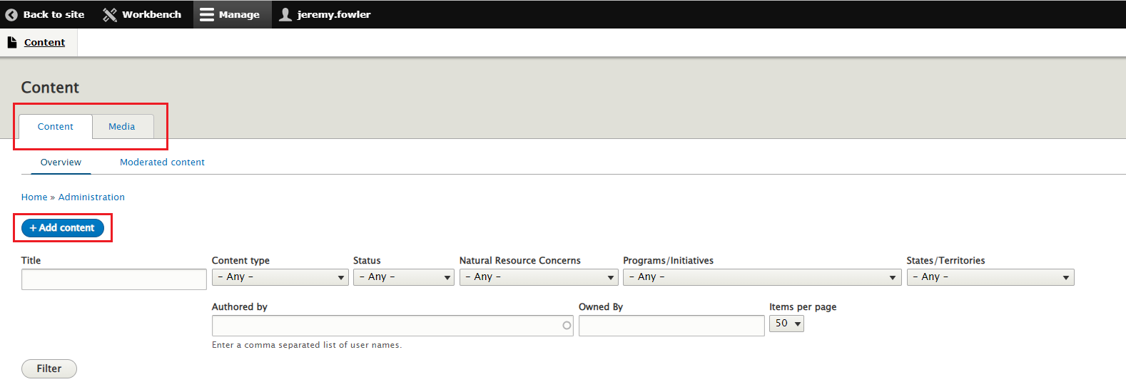

Content Types and Definitions:
Below are the nine (9) content types available to most users:
- Basic page
- Event
- FAQ
- Landing Page
- Location
- News
- Press
- Resource
- State Program/Initiative

Below are the six (6) content types available to Group (State, Soils, programs, etc) Users:
- Basic page
- Event
- FAQ
- News
- Resource
- State Program/Initiative

See below more details on each content type:

- Basic page: The Basic Page provides the fields you need to build pages with simple structures and design needs. As an all-purpose page, it can handle a variety of content that provides more depth and explanatory content on topics surfaced on other content types. It can also be used to build dedicated FAQ pages for a single topic focus.
- Event: The Event content type is used to advertise upcoming events, like conferences, webinars, or committee meetings throughout the webste
- FAQ: The FAQ type is used to input individual, specific questions users need answers to. FAQ groups can be featured as “top” questions on other content types like Natural Resources Concerns, States and Territories, or Programs and Initiatives, or a single topic can receive a dedicated page when all associated questions are grouped on a Basic content type.
- Landing Page: The Landing Page provides more robust fields needed to build first- and second- level pages in the sitemap. These pages serve as overviews of topics to navigate users into deeper, more detailed pages on the site. You can use a variety of components on the Landing Page content type that pull in relevant content based on taxonomy terms or other content types.
- Location: The Location type is used to input information for various location centers associated with NRCS.
- News: The News type is used to create content like news, press releases, success stories, and any other timely content that is published frequently.
- Press Release FAQ: Consists of an image, an optional hero image and a single body field for FAQ content related to a Press Release.
- Resource: The Resource type is used to identify and classify resource documents and assets. When resources exist on an outside site, a resource content type is used to provide descriptive information and links to the outside resource.
- State Program/Initiative: This is used for States to create a page which references a National Program/Incentive.

Another option to access All content types and sub-types is by clicking on Content. This will bring to an overview page with all the content types including search/filter options (see below example).

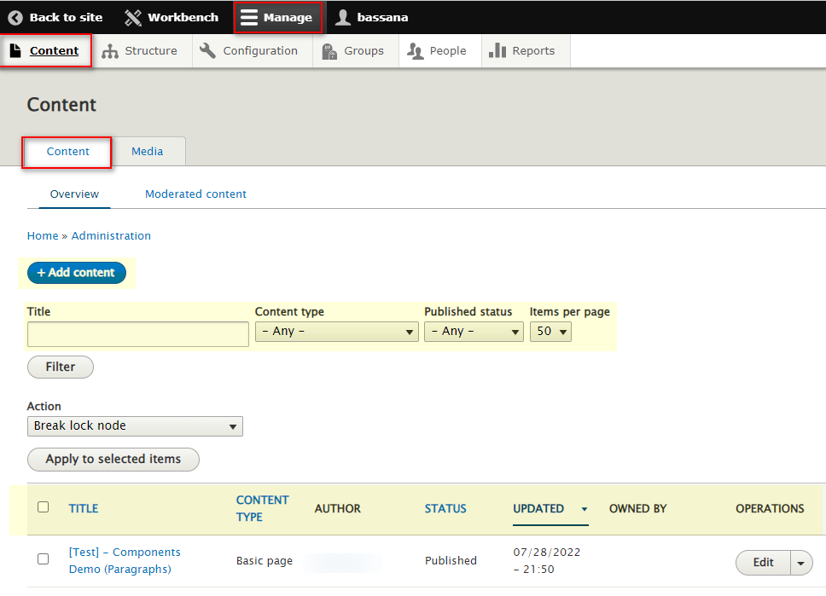

Additionally, the same view allows users to view all Media related content housed in Drupal (or you can “Add Media” items). Media items include:
- Document - An uploaded file or document, such as a PDF, Word, Excel, etc.
- *Image - Use local images for reusable media
  - Upload options: local PC upload and USDA Flicker Library
- YouTube - A remotely hosted video from YouTube

* To add new images, user can access the USDA Flickr account directly from the Flickr Library within Drupal

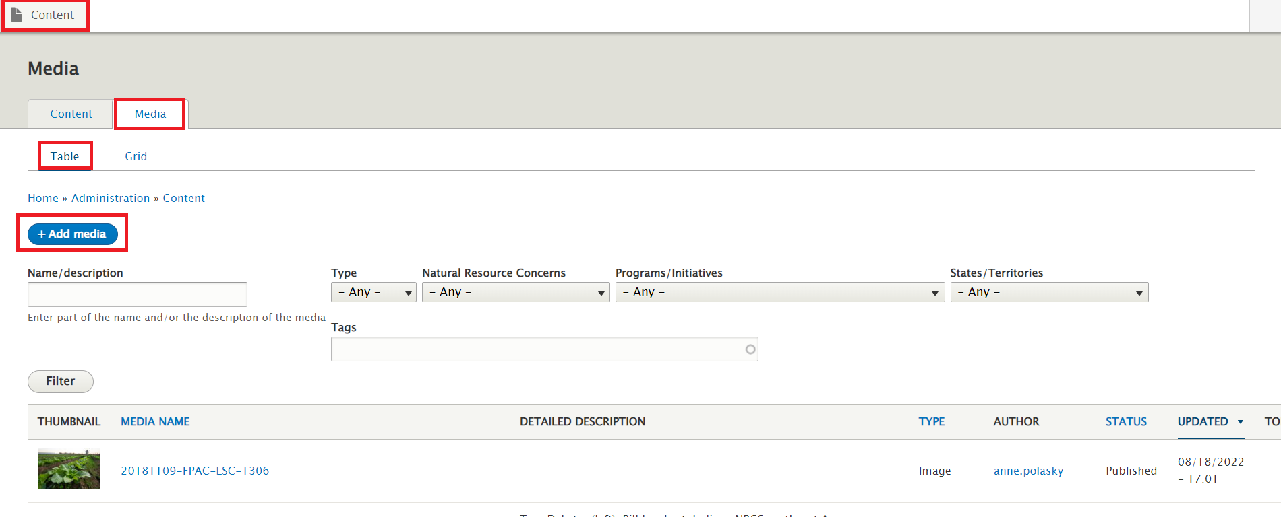
View 1 - Table

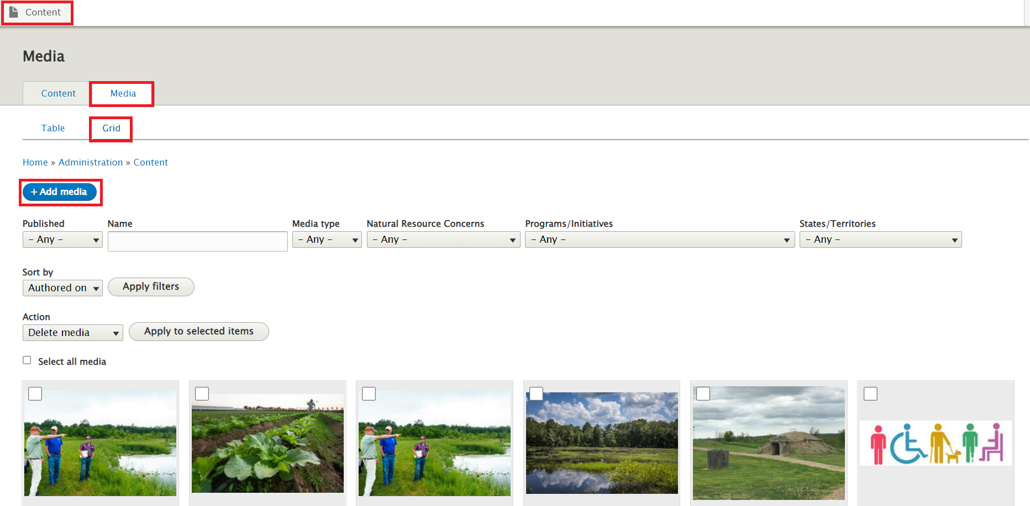
View 2 - Grid

Every user of this site is associated with one or more Groups to better manage the content on the website. You can only add or edit content for your Group(s).

Notice that only content belonging to your Group(s) displays with an “edit” button.

